**Intro and Background**

Ensuring on-time delivery in transportation and supply chain logistics is vital for maintaining service quality, store operations, and customer satisfaction. ADUSA Transportation at DC20 in Disputanta, Virginia, handles deliveries across a broad network of stores. The company set an ambitious goal to exceed a 93% on-time delivery rate across all routes, commodities, and store locations. However, over the past year, late deliveries have continued to impact operations, causing inefficiencies, disruptions, and potential customer dissatisfaction.

This project originated from a workplace need to uncover the key drivers behind delivery delays and identify opportunities for improving delivery timeliness. The effort builds on Phase 1 improvements on the warehouse side in 2022, including optimized staffing and scheduling. In Phase 2, a new driver schedule was implemented in early 2023 to align better with outbound load availability. Now, in Phase 3, the focus shifts to analyzing delivery performance using data to drive decisions.

Inspired by practical experience and supported by visualization techniques from sources like the MIT Sloan article on storytelling with data (Dykes, 2016), this project aims to present a compelling narrative using charts and dashboards. The main questions addressed include:

* What is the overall on-time delivery performance at DC20 in 2023?
* Which stores have the highest late delivery rates?
* Are certain commodities or times of day more prone to late deliveries?
* How do arrival times compare to scheduled delivery windows?

By answering these questions, the project delivers insights that benefit both logistics leadership and store operations teams. Ultimately, it supports data-driven decisions that can reduce late deliveries and enhance service performance.

**Datasets**

The dataset used in this project is sourced from internal company records at ADUSA Transportation DC20 for calendar year 2023. It consists of 93,183 records that include details about each delivery trip: commodity type, dispatch and arrival dates and times, route number, store number, and calculated fields such as delivery duration and minutes late or early.

* **Source:** Internal operational data from ADUSA DC20
* **Timeframe:** January 1, 2023 to December 31, 2023
* **Collected by:** Transportation team, extracted from delivery tracking systems, CAMS Prospero
* **Purpose:** To track and analyze delivery efficiency and identify performance trends
* **Key variables:** Arrival status (late, on-time, early), store number, route number, scheduled delivery windows, actual arrival times, minutes early or late, and delivery duration
* **Size:** 93,183 observations with over 20 variables

The dataset provides all the necessary fields to measure and assess delivery timeliness, perform store-level comparisons, and evaluate performance across commodities. Fields such as "Minutes Late," "Arrive Stop Time," and "Scheduled Start/End Time" enable precise analysis of delays.

**Data Story**

Seven key visualizations were developed in Tableau to support this analysis. These were organized into a dashboard and storyboard to highlight patterns, identify outliers, and support decision-making.

1. **Overall On-Time Delivery Pie Chart**  
   This pie chart shows the percentage of all deliveries categorized as "On-Time" vs. "Late." Out of 93,183 deliveries, approximately 10.23% were late. This visualization provides a high-level view of performance and reinforces the need to improve from ~90% to the target of 93% on-time.

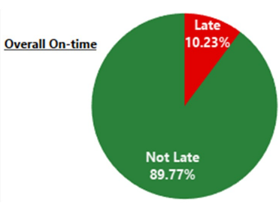

**Figure 1.** Overall on-time vs. late delivery rate for all 2023 deliveries at ADUSA DC20.

1. **Delivery % by Month (Stacked Bar Chart)**  
   This chart tracks the percentage of on-time and late deliveries by month. Notable spikes in late deliveries occurred in June and November, both exceeding 13%. It highlights seasonal variation and suggests periods where performance improvement efforts could be focused.

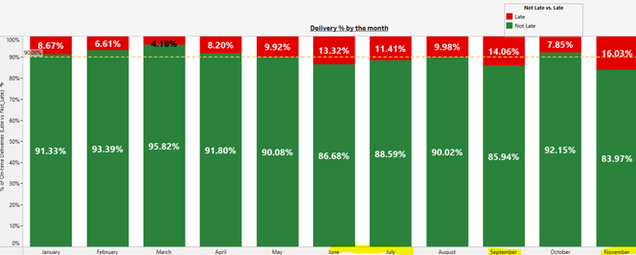

**Figure 2.** Delivery % by the months for all 2023 deliveries at ADUSA DC20.

1. **Late % by Store (>10%)**  
   This horizontal bar chart displays only stores that had 10.1% or more of their deliveries arrive late. Some stores had a late percentage as high as 45.9%. This visualization identifies the worst-performing stores and supports targeted improvements.
2. **Late % by Commodity (Pie Chart)**  
   A breakdown of late deliveries by commodity type revealed that Grocery (GRO) and Frozen (FRO) categories accounted for the largest shares of delays. This supports further investigation into whether certain goods are more difficult to deliver on time.
3. **Average Late Minutes per Store (Bar Chart)**  
   This chart identifies which stores experience not just frequent late deliveries but also longer delays. Store 156 had the highest average delay at 25.75 minutes, indicating a possible route or scheduling issue.
4. **Arrival Time vs. Scheduled Window (Scatter Plot)**  
   A detailed scatter plot compares the actual arrival times of deliveries to their scheduled time windows. Stores with high late percentages often had clustered red marks (late arrivals) outside the expected window. This visual validates that many delays occurred after the scheduled end time.
5. **Final KPI Dashboard (Summary View)**  
   The full dashboard combines all key metrics, including:
   * Total deliveries: 93,183
   * Average minutes late (overall): 4.62
   * Average stop duration: 20.26 minutes
   * Filters for store, commodity, and dispatch date

Interactivity allows users to drill down by commodity or store and evaluate custom views. This helps tailor improvement strategies for specific areas.

Each of these visualizations was constructed using clean and prepared fields from the original dataset. Filters, calculated fields (such as "Not Late" vs. "Is Late"), and formatting were applied to maximize clarity and insight.

**Summary & Recommends**

The results of this analysis show that while DC20 is performing near its on-time target, there is significant room for improvement, especially with specific stores and commodity types. Key findings include:

* **Overall late delivery rate:** 10.23%, just above the target threshold
* **Several stores have chronic late delivery issues**, with some exceeding 40% late
* **Frozen and grocery commodities contribute most to late arrivals**
* **Late deliveries cluster outside scheduled time windows**, pointing to scheduling as a factor

Recommendations:

1. **Reevaluate and extend scheduled time windows** at stores with high late rates, especially those with narrow windows under two hours.
2. **Reschedule dispatch times or reroute deliveries** to optimize arrival times based on delay trends.
3. **Monitor commodity-specific loading and transport delays**, especially for frozen goods.
4. **Use the Tableau dashboard as a live monitoring tool** to track improvement over time.

While this analysis provides meaningful insights, it is limited by the absence of contextual data such as the drivers’ schedule, warehouse loaders’ schedule of making trailers for delivery ready, traffic conditions, and weather impacts. Incorporating these elements could improve predictive models in the future.

In conclusion, this project has demonstrated how data visualization and storytelling can support meaningful changes in operational performance. By applying the principles of effective data communication, this work translates raw delivery data into actionable insights that ADUSA Transportation can use to exceed its 93% on-time goal.